XFUSION Centreon Plug-in
v1.1
User Guide
 | Date | 2022-03-30
 | Copyright © Copyright Holder. All rights reserved.

Notice
The information in this document is subject to change without notice. Every effort has been made in the preparation of this document to ensure accuracy of the contents, but all statements, information, and recommendations in this document do not constitute a warranty of any kind, express or implied.

Contents
About This Document iii
1 Introduction 5
2 Using centreon (Version 21.10.0) 7
2.1 Monitoring the Server Health Status 7
2.1.1 Installing and Uninstalling the centreon Plug-in 7
2.1.1.1 Installing the centreon Plug-in 7
2.1.1.2 Uninstalling the centreon Plug-in 8
2.1.2 Configuring the Server Health Status Monitoring Function 8
2.1.2.1 Configuring a Command 8
2.1.2.2 Configuring a Host 13
2.1.2.3 Configuring a Service 15
2.1.2.4 Generating a Configuration File and Making the ConfigurationTake Effect 17
2.1.3 Viewing the Server Status 17
2.2 Receiving Server SNMP Alarms 18
2.2.1 Configuring Server Trap Parameters 18
2.2.1.1 Configuring a Rack/High-Density Server 18
2.2.1.2 Configuring a Blade Server 19
2.2.2 Receiving SNMPv2c Alarms 20
2.2.2.1 Importing the MIB File 20
2.2.2.2 Configuring a Receiving Host 22
2.2.2.3 Creating a Service and Associating it with a Host and a Trap 23
2.2.2.4 Generating a Configuration File and Making the ConfigurationTake Effect 25
2.2.2.5 Receiving Alarms 26
2.2.3 Receiving SNMPv3 Alarms 26
2.2.3.1 Configuring a Receiving Host 26
2.2.3.2 Creating a Service and Associating it with a Host and a Trap 27
2.2.3.3 Generating a Configuration File and Making the ConfigurationTake Effect 29
2.2.3.4 Receiving Alarms 30
A Obtaining Technical Support 31
B Communication Matrix 32

About This Document
Overview
This document describes how to install and uninstall the centreon plug-in, view server health status, and receive SNMP trap alarms.
Intended Audience
This document is intended for:
- Technical support engineers
- Maintenance engineers
Symbol Conventions
The symbols that may be found in this document are defined as follows.
Symbol | Description
 | Indicates an imminently hazardous situation which, if not avoided, will result in death or serious injury.
 | Indicates a potentially hazardous situation which, if not avoided, could result in death or serious injury.
 | Indicates a potentially hazardous situation which, if not avoided, could result in minor or moderate injury.
 | Indicates a potentially hazardous situation which, if not avoided, could result in equipment damage, data loss, performance deterioration, or unanticipated results.  NOTICE is used to address practices not related to personal injury.
Calls attention to important information, best practices, and tips.
NOTE is used to address information not related to personal injury, equipment damage, and environment deterioration.

Change History
Issue | Date | Description
01 | 2022-03-30 | This issue is the first official release.

Introduction
The centreon plug-in is a plug-in integrated on the centreon platform. The plug-in uses SNMP to connect to the iBMC or HMM to monitor servers.
You can implement the following functions by using this plug-in:
- Use SNMPv1, SNMPv2c, and SNMPv3 to view the health status of servers and components.
- Receive SNMPv2c and SNMPv3 trap alarms of all server components.
The centreon plug-in supports the following servers and components:
- Table Supported servers by the centreon plug-in lists the servers supported by the centreon plug-in.
- Table Supported components by the centreon plug-in lists the components that support the health check function of the centreon plug-in.
                - Supported servers by the centreon plug-in
Type | Server
Rack server | RH2288H V2
Rack server | RH1288 V3
Rack server | RH2288 V3
Rack server | RH2288H V3
Rack server | RH5288 V3
Rack server | RH8100 V3
Rack server | 1288H V5
Rack server | 2288H V5
Rack server | 2488 V5
Rack server | 1288H V6
Rack server | 2288H V6
High-density server | XH321 V3
High-density server | XH620 V3
High-density server | XH622 V3
High-density server | XH628 V3
High-density server | XH321 V5
Blade server | E9000(HMM910)

                - Supported components by the centreon plug-in
Server Type | Component
Rack/high-density server | CPU, PSU, fan, memory, RAID controller card, drive, and system health status
Blade server | PSU, fan, SMM, chassis, switch module, and compute node status, compute node CPU, memory, drive, RAID controller card, and mezzanine card

Using centreon (Version 21.10.0)
In this chapter, centreon Web 21.10.0 are used.
2.1 Monitoring the Server Health Status
2.2 Receiving Server SNMP Alarms

Monitoring the Server Health Status

Installing and Uninstalling the centreon Plug-in

Installing the centreon Plug-in
Procedure
            - Use the SSH mode (such as PuTTY) to log in to the centreon server.
            - Run the following commands to install the official centreon plug-in:
# yum install git
# git clone https://github.com/centreon/centreon-plugins.git
            - Copy the centreon-plugins folder from the current directory to the installation directory, for example, /usr/local/.
            - Install the plug-in extension package that supports the XFUSION server.
- Run the following command to switch to the centreon server directory:
cd /tmp
- Run the following command to download the centreon plug-in software package,obtain the Centreon plug-in software package (for example, XFUSION Centreon Plugin v1.1.zip) and its SHA256 verification file (for example, XFUSION Centreon Plugin v1.1.sha256.sum):
#git clone https://github.com/Open-xFusion/Server_Plugin_Centreon.git
- Verify the integrity of the Centreon plug-in software package.
  - Go to the directory where the plug-in software package and SHA256 verification file are stored.
  - Run the sha256sum -c < (grep 'software package name' 'sha256 verification file name') command to verify the software package.
Example: sha256sum -c <(grep 'XFUSION Centreon Plugin v1.1.zip' 'XFUSION Centreon Plugin v1.1.sha256.sum')
  - Check whether the verification result is OK.
  - If yes, the software package has not been tampered with and can be used.
  - If no, the software package has been tampered with. Obtain a new software package.
- Go to the /Server_Management_Plugin_Centreon/releases directory and run the following command to decompress the centreon plug-in software package:
unzip -d /tmp XFUSION\Centreon\Plugin\ vX.X.zip
- Run the following command to copy the content from the hardware/ directory in the decompressed package to the hardware/ directory in the centreon installation directory. For example, if the directory where the hardware directory of centreon is located is /usr/local/centreon-plugins, run the following command:
cp -rf /tmp/src/hardware /usr/local/centreon-plugins/
chmod -R 755 /usr/local/centreon-plugins/hardware/server/XFUSION
chmod -R 755 /usr/local/centreon-plugins/hardware/v5server/XFUSION
----End

Uninstalling the centreon Plug-in
            - Use the SSH mode (such as PuTTY) to log in to the centreon server.
            - Find the hardware/server/XFUSION directory in the plug-in installation directory, and run the following command to delete the directory:
rm -rf /usr/local/centreon-plugins/hardware/server/XFUSION
rm -rf /usr/local/centreon-plugins/hardware/v5server/XFUSION
----End

Configuring the Server Health Status Monitoring Function
Perform the following operations to implement the function of server health status monitoring.

Configuring a Command
            - Log in to centreon.
- Open the browser, enter http://centreon IP address/centreon in the address box, and press Enter.
- Enter the user name and password, and click Login.
The centreon home page is displayed, as shown in Figure 2-1.
              - Home page of centreon
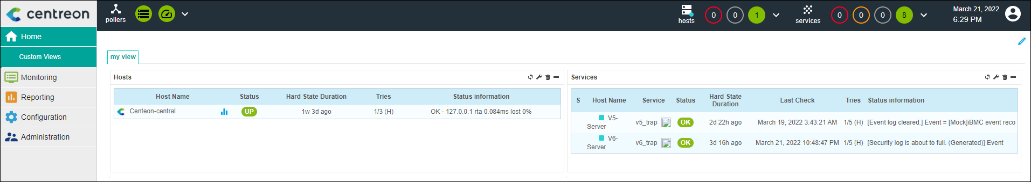

            - Choose Configuration > Commands > Checks.
The Checks page is displayed, as shown in Figure 2-2.
              - Checks page
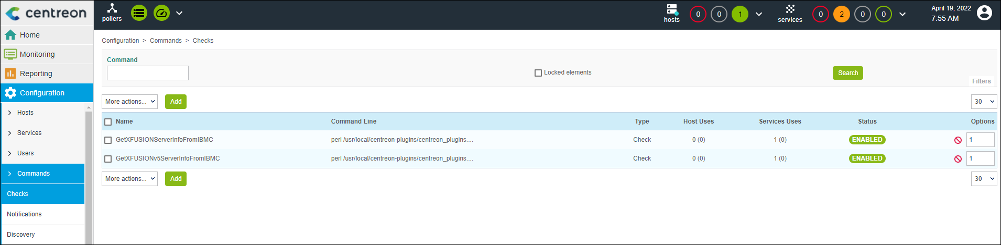

            - Click Add.
The page for adding a command is displayed, as shown in Figure 2-3.
              - Page for adding a command
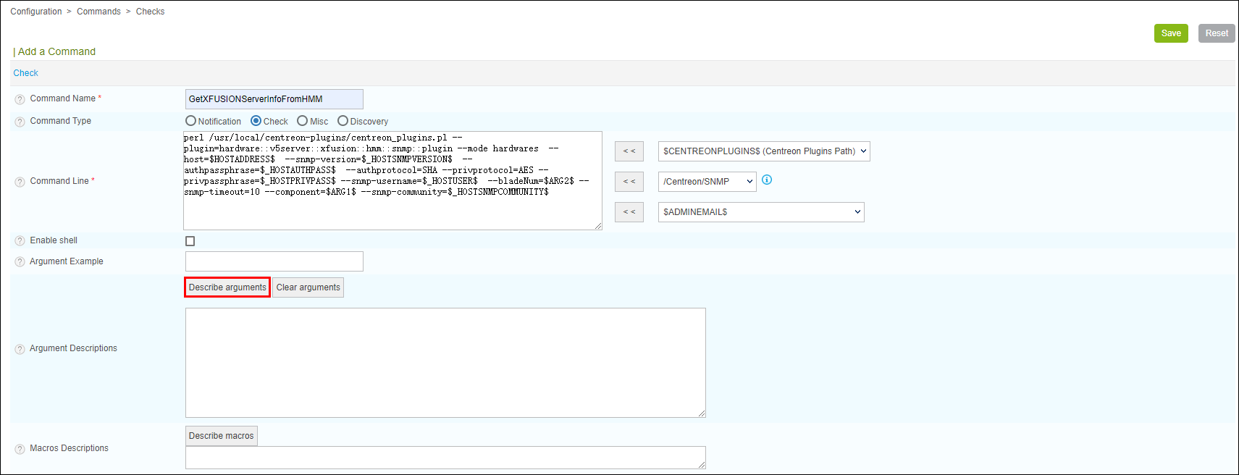

Add a command for a blade server or high-density/rack V5 or earlier than V5 server or high-density/rack V6 server.
- Add a command for a blade server.
  - Enter a name in Command Name, for example, GetXFUSIONServerInfoFromHMM.
  - Add the following command to Command Line:
perl /usr/local/centreon-plugins/centreon_plugins.pl --plugin=hardware::v5server::xfusion::hmm::snmp::plugin --mode hardwares --host=$HOSTADDRESS$ --snmp-version=$_HOSTSNMPVERSION$ --authpassphrase=$_HOSTAUTHPASS$ --authprotocol=SHA --privprotocol=AES --privpassphrase=$_HOSTPRIVPASS$ --snmp-username=$_HOSTUSER$ --bladeNum=$ARG2$ --snmp-timeout=10 --component=$ARG1$ --snmp-community=$_HOSTSNMPCOMMUNITY$
  - Click Describe arguments, and enter bladeNum and component.
- Add a command for a high-density/rack server.
- V5 or earlier than V5 server:
    - Enter a name in Command Name, for example, GetXFUSIONv5ServerInfoFromIBMC.
    - Add the following command to Command Line:
perl /usr/local/centreon-plugins/centreon_plugins.pl --plugin=hardware::v5server::xfusion::ibmc::snmp::plugin --mode hardwares --host=$HOSTADDRESS$ --snmp-version=$_HOSTSNMPVERSION$ --authpassphrase=$_HOSTAUTHPASS$ --authprotocol=SHA --privprotocol=AES --privpassphrase=$_HOSTPRIVPASS$ --snmp-username=$_HOSTUSER$ --snmp-timeout=3 --component=$ARG1$ --snmp-community=$_HOSTSNMPCOMMUNITY$
    - Click Describe arguments, and enter component.
- V6 Server:
    - Enter a name in Command Name, for example, GetXFUSIONServerInfoFromIBMC.
    - Add the following command to Command Line:
perl /usr/local/centreon-plugins/centreon_plugins.pl --plugin=hardware::server::xfusion::ibmc::snmp::plugin --mode hardwares --host=$HOSTADDRESS$ --snmp-version=$_HOSTSNMPVERSION$ --authpassphrase=$_HOSTAUTHPASS$ --authprotocol=SHA --privprotocol=AES --privpassphrase=$_HOSTPRIVPASS$ --snmp-username=$_HOSTUSER$ --snmp-timeout=3 --component=$ARG1$ --snmp-community=$_HOSTSNMPCOMMUNITY$
    - Click Describe arguments, and enter component.

Set /usr/local/centreon-plugins/centreon_plugins.pl based on the installation location of the plug-in.
Table 2-1 describes the command parameters.
                - Command parameter description
Parameter | Description | Mandatory or Optional | Example Value Description
--mode | The default value is hardwares and does not need to be changed. | Mandatory | -
--host | Specifies the IP address of the managed host. | Mandatory | In the example command, this parameter is set to $HOSTADDRESS$, which indicates that the value is transferred from the associated host configuration.
--snmp-version | Specifies the SNMP version used. | Mandatory | In the example command, this parameter is set to $_HOSTSNMPVERSION$, which indicates that the value is transferred from the associated host configuration.
--authpassphrase | Specifies the authentication password of SNMPv3. This parameter applies only to SNMPv3. | Optional | In the example command, this parameter is set to $_HOSTAUTHPASS$, which indicates that the value is transferred from the associated host configuration.
--authprotocol | Specifies the encryption protocol of SNMPv3. This parameter applies only to SNMPv3, and the value must be the same as that configured on the monitored server. | Optional | -
--privprotocol | Specifies the authentication protocol of SNMPv3. This parameter applies only to SNMPv3, and the value must be the same as that configured on the monitored server. | Optional | -
--privpassphrase | Specifies the authentication password of SNMPv3. This parameter applies only to SNMPv3. | Optional | In the example command, this parameter is set to $_HOSTPRIVPASS$, which indicates that the value is transferred from the associated host configuration.
--snmp-username | Specifies the SNMP user name. This parameter applies only to SNMPv3. | Optional | In the example command, this parameter is set to $_HOSTUSER$, which indicates that the value is transferred from the associated host configuration.
--bladeNum | Specifies the slot number of the compute node to be monitored. This parameter applies only to blade servers. | Mandatory for the monitoring of compute nodes | In the example command, this parameter is set to $ARG2$, which indicates that the value is transferred from the service configuration.
--snmp-timeout | Specifies the SNMP timeout interval. The default value is 1. | Optional | - The recommended value is 3 for high-density and rack servers.  - The minimum value is 10 for blade servers.
--component | Specifies the server component to be monitored.  - High-density and rack servers support the following values: system/cpu/fan/raid/memory/psu/disk  - Blade servers support the following values: system/cpu/fan/raid/memory/psu/disk/blade/shelf/switch/mezz/smm | Mandatory | In the example command, this parameter is set to $ARG1$, which indicates that the value is transferred from the service configuration.
--SNMP-community | Specifies the community name. This parameter applies to SNMPv2c and SNMPv1. | Optional | In the example command, this parameter is set to $_HOSTSNMPCOMMUNITY$, which indicates that the value is transferred from the associated host configuration.
--snmp-port | Specifies the SNMP port number. The default value is 161. | Optional | In the example command, this parameter is not set, and the default value is used.
--snmp-retries | Specifies the SNMP retry interval. The default value is 5. | Optional | In the example command, this parameter is not set, and the default value is used.

            - Click Save.
The command is added successfully.
----End

Configuring a Host
            - Choose Configuration > Hosts > Hosts.
The Hosts page is displayed, as shown in Figure 2-4.
              - Hosts page
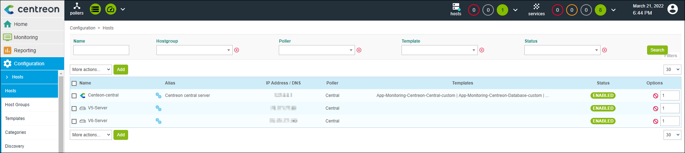

            - Click Add.
On the Add a Host page that is displayed, set the following parameters, as shown in Figure 2-5.
- Name: specifies the server host name.
- Alias: specifies the host alias.
- IP Address/DNS: specifies the server IP address.
- SNMP Community & Version: specifies the SNMP community name and version. The version must be the same as that configured on the server. The community name is required only when the version is v1 or v2c.
If SNMPv3 is used, click Add a new entry in Custom macros to add the following information about SNMPv3:
- PRIVPASS: specifies the encryption password of SNMPv3.
- AUTHPASS: specifies the authentication password of SNMPv3.
- USER: specifies the user name of SNMPv3.
              - Add a Host page
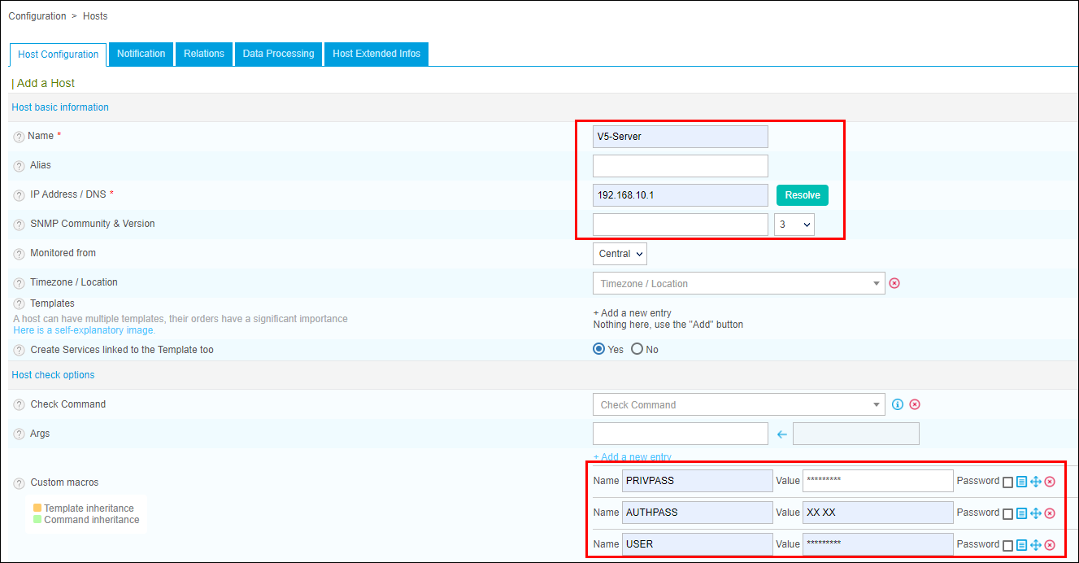

            - Click Save.
The host is configured.
----End

Configuring a Service
            - Choose Configuration > Services > Services by host.
The Services by host page is displayed, as shown in Figure Services by host page.
              - Services by host page
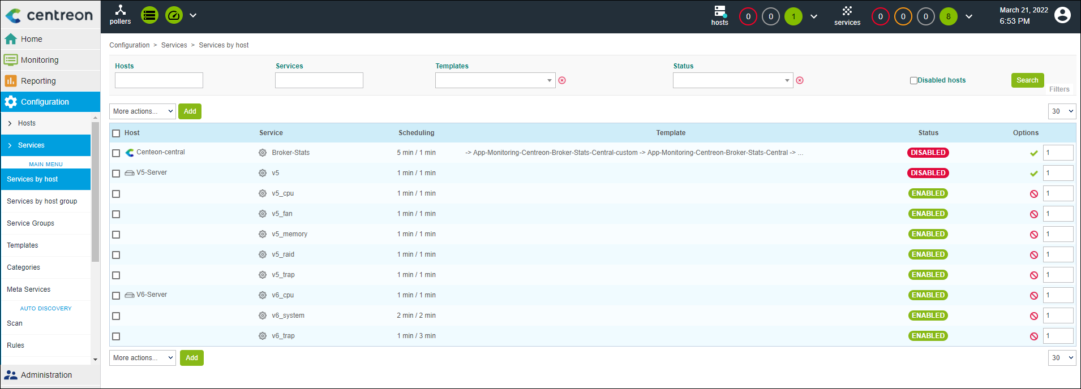

            - Click Add.
On the Add a Service page that is displayed, set related parameters, as shown in Figure 2-7.
              - Add a Service page
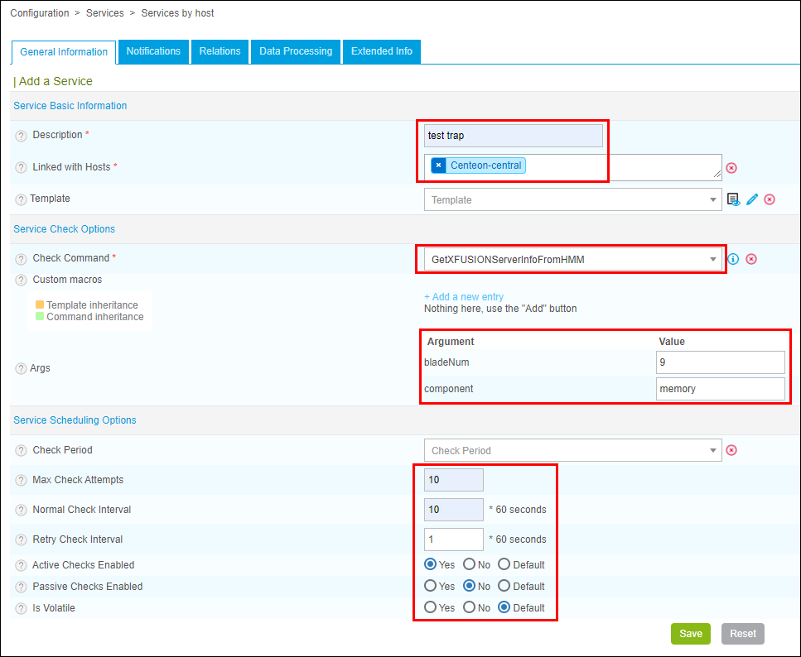

The parameters are described as follows:
- Description: specifies the name of the service to be added.
- Linked with Hosts: specifies the directly connected host. You can select the host added in 2.1.2.2 Configuring a Host.
- Check Command: You can select the command added in 2.1.2.1 Configuring a Command.
- Args:
- bladeNum: specifies the slot number of the compute node. This parameter is supported only by blade servers.
- component: specifies the server component to be monitored. For details about the value range, see Table 2-1.
- Max Check Attempts: specifies the maximum retry times.
- Normal Check Interval: specifies the regular monitoring interval.
- Retry Check Interval: specifies the interval for retrying monitoring.
- Active Checks Enabled: specifies whether to enable proactive monitoring. Set this parameter to Yes.
- Passive Checks Enabled: specifies whether to enable passive monitoring. Set this parameter to No.
- Is Volatile: Set this parameter to Default.
            - Click Save.
The service is configured.
----End

Generating a Configuration File and Making the ConfigurationTake Effect
            - Choose Configuration > Pollers > Pollers.
The Pollers page is displayed, as shown in Figure 2-8.
              - Pollers page
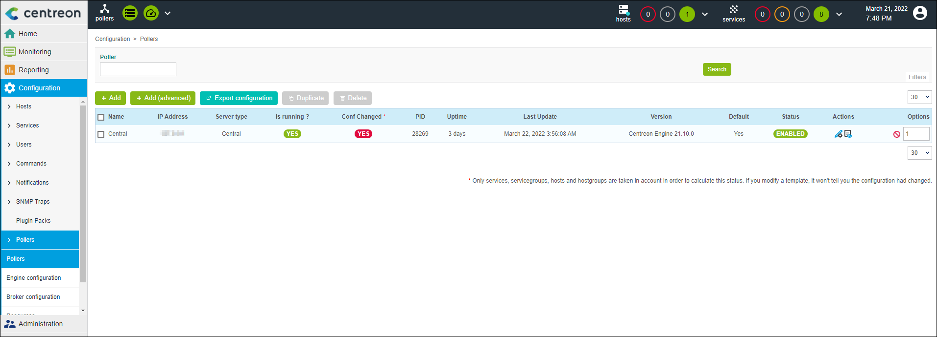

            - Select an available poller, and click Export Configuration.
            - Select all parameters in Actions, and click Export.
If Total Errors: 0 is displayed in the export results, the export is successful and the configuration takes effect.
              - Configuration Files Export page
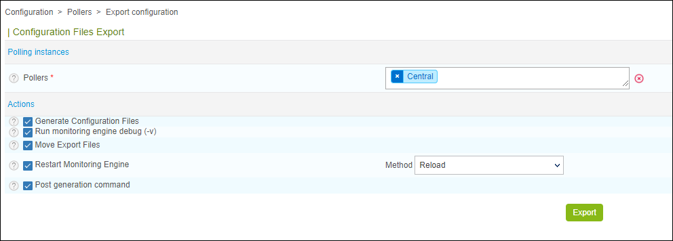

----End

Viewing the Server Status
            - Choose Monitoring > Resources Status. Select All from the Service Status drop-down list box to view the status of all monitored hosts.
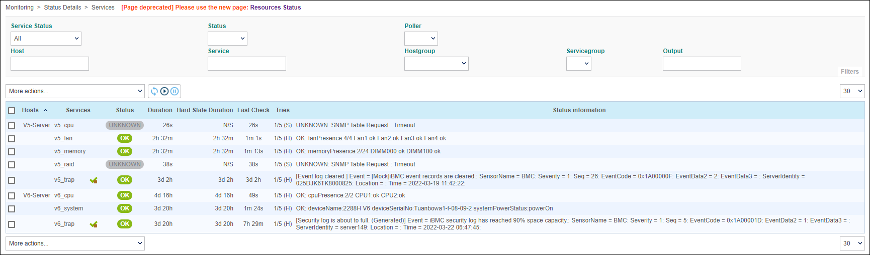
----End

Receiving Server SNMP Alarms
SNMP trap alarms can be received only in SNMPv2c and SNMPv3.
Prerequisites
To receive SNMPv3 alarms, you need to download the MIB Browser tool to view the engine ID of the server.

Configuring Server Trap Parameters

Configuring a Rack/High-Density Server
            - Log in to the iBMC of the rack/high-density server. For details, see the iBMC user guide of the corresponding product.
            - Choose Alarm & SEL > Alarm Settings, enable the trap function, and set the following parameters, as shown in Figure 2-10.
- Trap Version: Select the corresponding version according to the actual situation.
- Trap Mode: Select OID.
- Set the following parameters in the Trap Server and Message Format area:
- Trap Server Address: Enter the centreon server IP address.
- Trap Port: Enter 162.
              - iBMC alarm settings
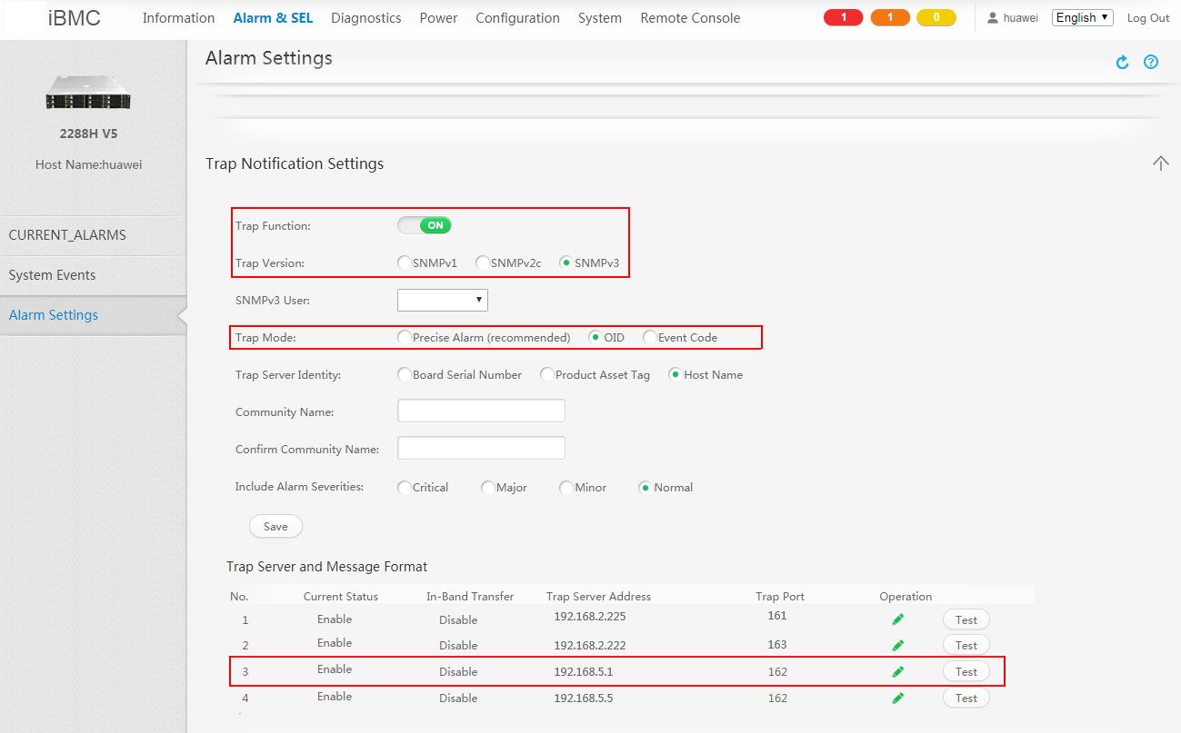

----End

Configuring a Blade Server
            - Log in to the HMM WebUI of the blade server. For details, see the MM910 Management Module User Guide.
            - Choose Chassis Settings > Network Settings > MM. In SNMP TrapConfiguration, set Trap to Enable, and set the following parameters:
- Trap version: Select the corresponding version according to the actual situation.
- Trap mode: Select OID mode.
- Trap port number: Enter 162.
- Trap address: Enter the centreon server IP address.
              - HMM SNMP trap configuration
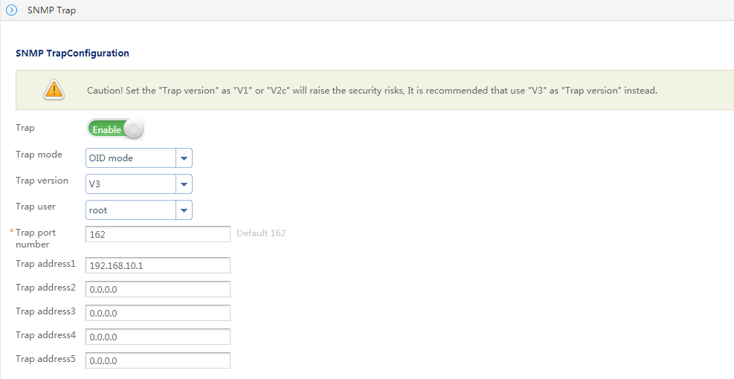

----End

Receiving SNMPv2c Alarms

Importing the MIB File
            - Log in to centreon.
- Open the browser, enter http://centreon IP address/centreon in the address box, and press Enter.
- Enter the user name and password, and click Login.
The centreon home page is displayed, as shown in Figure 2-12.
              - Home page of centreon

            - Choose Configuration > SNMP Traps > Manufacturer. The Manufacturer page is displayed,as shown in Figure Manufacturer Page.
              - Manufacturer Page
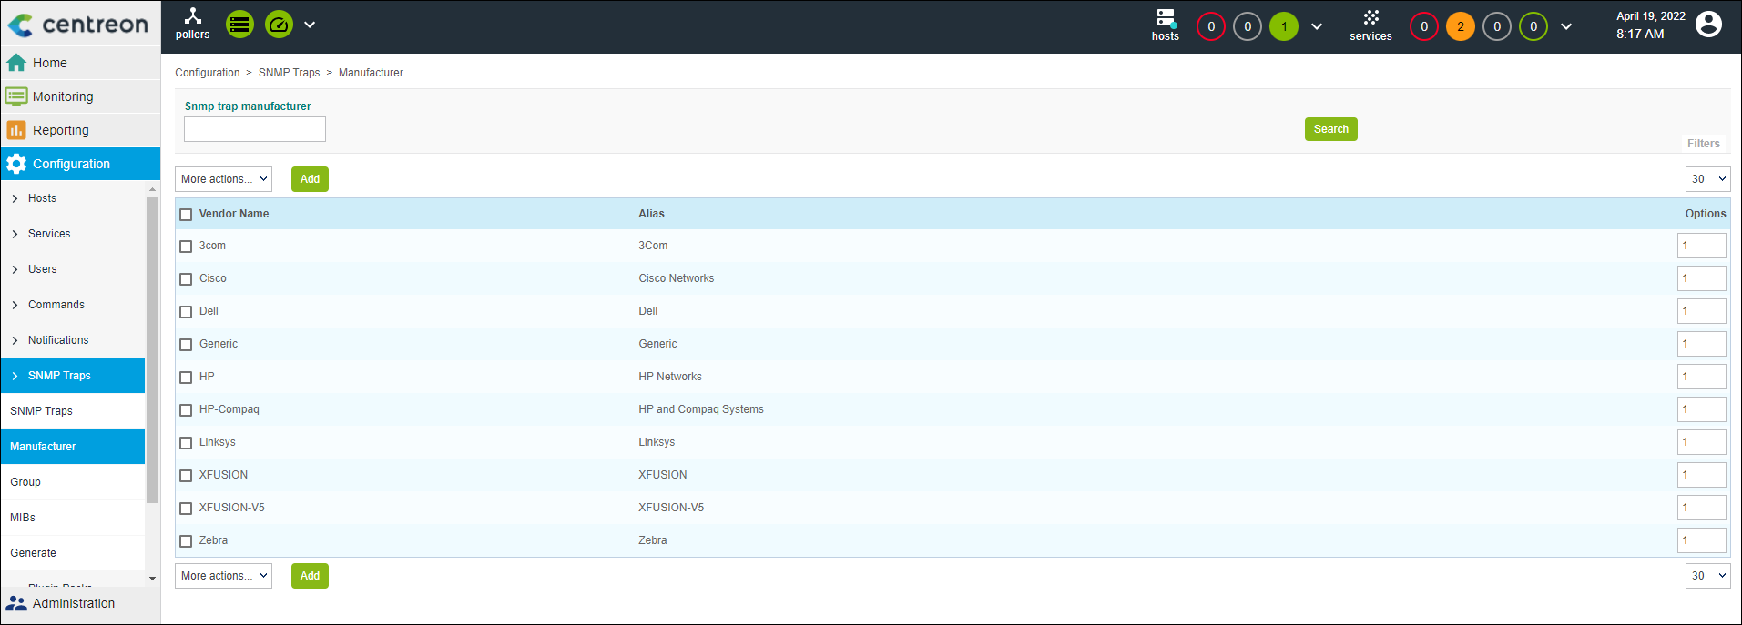

            - click Add.
Add a vendor and click Save, as shown in Figure 2-14.
The parameters are described as follows:
V5 or earlier than V5 server:
- Vendor Name: Enter XFUSION-V5.
- Alias: Enter an alias.
V6 Server:
- Vendor Name: Enter XFUSION.
- Alias: Enter an alias.
              - Add Vendor page
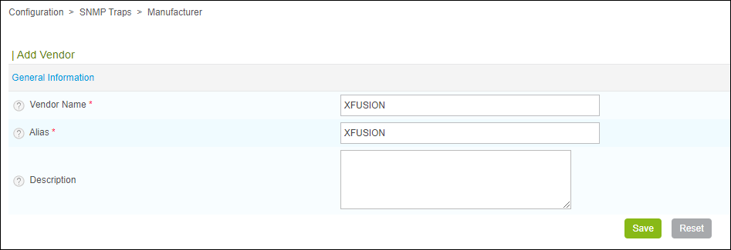

            - Install the plug-in extension package that supports XFUSION servers.
- Run the following command to switch to the centreon server directory:
cd /tmp
- Run the following command to download the centreon plug-in software package:
#git clone https://github.com/Open-xFusion/Server_Plugin_Centreon.git
- Go to the /Server_Management_Plugin_Centreon/releases directory and run the following command to decompress the centreon plug-in software package:
tar -xvf XFUSION\Centreon\Plugin\ vX.X.tar
            - Run the following commands to go to the directory and import the iBMC or HMM MIB file to XFUSION.
- Run the following commands for a high-density/rack server:
- V5 or earlier than V5 server:
cd /tmp/src/
perl importMib.pl -f XFUSIONmib/v5BmcForCentreon.mib -m XFUSION-V5
- V6 Server:
cd /tmp/src/
perl importMib.pl -f XFUSIONmib/bmcForCentreon.mib -m XFUSION
- Run the following commands for a blade server:
cd /tmp/src/
perl importMib.pl -f XFUSIONmib/hmmForCentreon.mib -m XFUSION
            - Choose Configuration > SNMP Traps > Generate, select an available poller, set Send Signal to Restart, select all parameters in Actions, and click Generate. The trap configuration is generated, as shown in Figure 2-15.
              - Page for generating the trap configuration
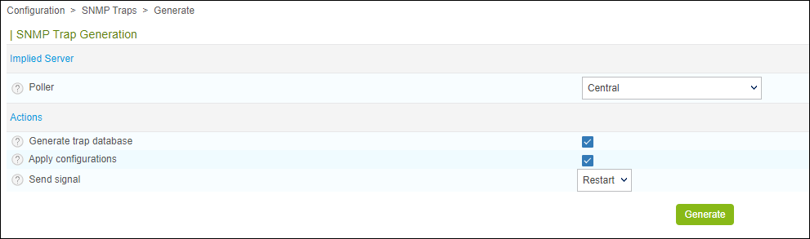

----End

Configuring a Receiving Host
            - Log in to centreon.
- Open the browser, enter http://centreon IP address/centreon in the address box, and press Enter.
- Enter the user name and password, and click Login.
The centreon home page is displayed, as shown in Figure 2-16.
              - Home page of centreon

            - Choose Configuration > Hosts > Hosts.
The Hosts page is displayed, as shown in Figure 2-17.
              - Hosts page

            - Click Add.
The Add a Host page is displayed.
Set the following parameters, as shown in Figure 2-18.
- Name: specifies the server host name.
- IP Address/DNS: specifies the server IP address.
              - Add a Host page
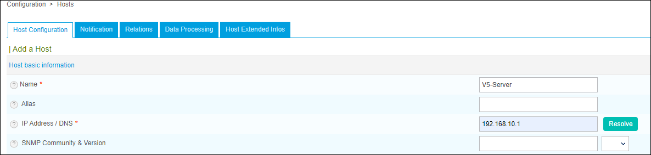

            - Click Save.
----End

Creating a Service and Associating it with a Host and a Trap
            - Choose Configuration > Services > Services by host.
The Services by host page is displayed, as shown in Figure Services by host page.
              - Services by host page
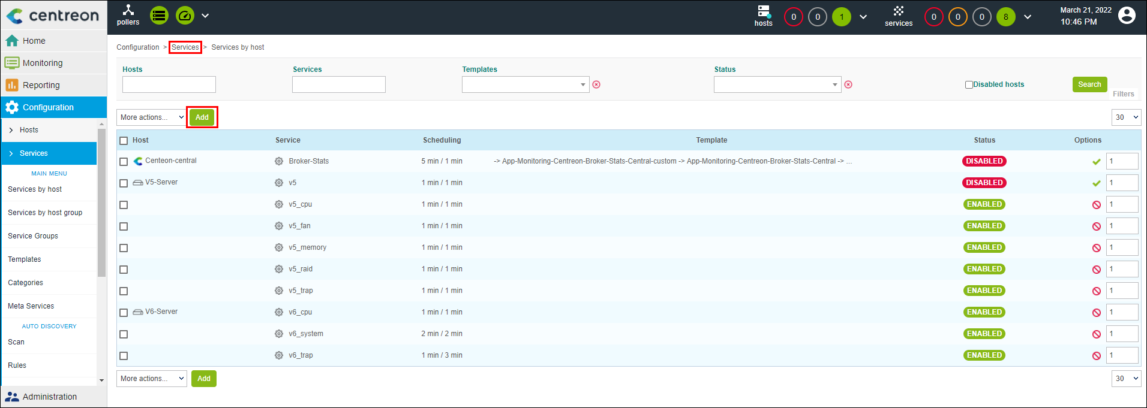

            - Click Add. The Add a Service page is displayed.
On the General Information tab, set the following parameters, as shown in Figure 2-20.
              - Add a Service page
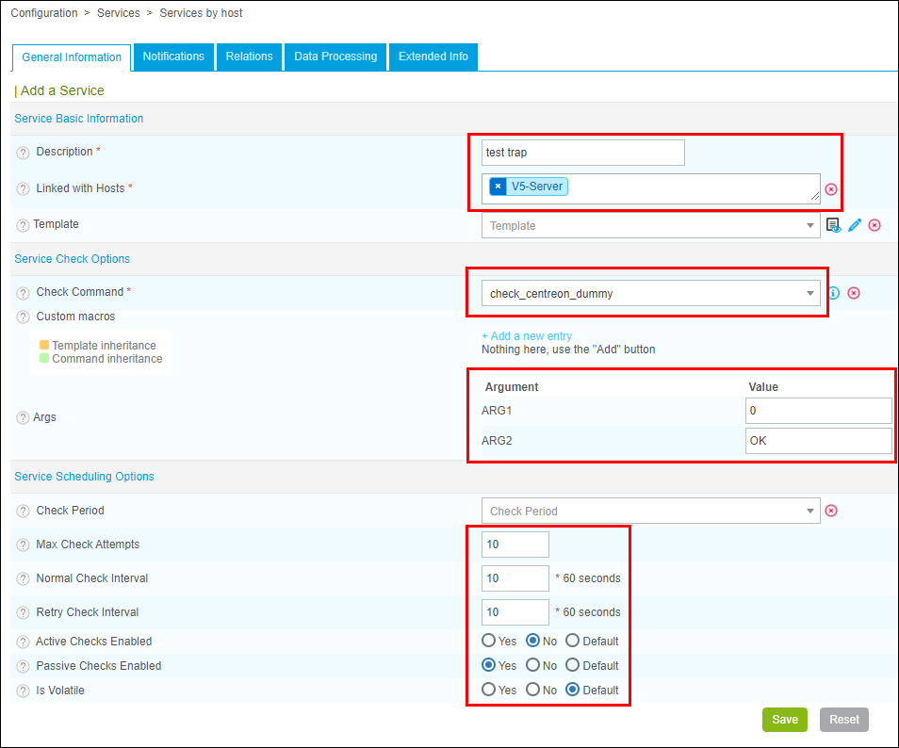

The parameters are described as follows:
- Description: specifies the name of the service to be added.
- Linked with Hosts: specifies the directly connected host. You can select the host added in 2.2.2.2 Configuring a Receiving Host.
- Check Command: Select Check_centreon_dummy.
- Args:
- ARG1: Enter 0.
- ARG2: Enter OK.
- Max Check Attempts: specifies the maximum retry times.
- Normal Check Interval: specifies the regular monitoring interval.
- Retry Check Interval: specifies the interval for retrying monitoring.
- Active Checks Enabled: specifies whether to enable proactive monitoring. Set this parameter to No.
- Passive Checks Enabled: specifies whether to enable passive monitoring. Set this parameter to Yes.
- Is Volatile: Set this parameter to Default.
            - On the Relations tab, enter the associated trap information, as shown in Figure 2-21.
              - Add relations page
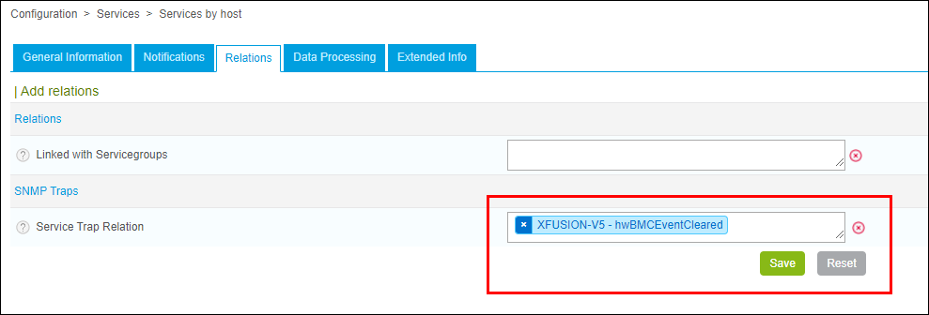

Associating with too many SNMP Traps may cause service creation failure. Select according to the requirements of your service. It is recommended that the number of associated Traps be within 1000.
            - Click Save.
----End

Generating a Configuration File and Making the ConfigurationTake Effect
            - Choose Configuration > Pollers > Pollers.
The Pollers page is displayed, as shown in Figure 2-22.
              - Pollers page
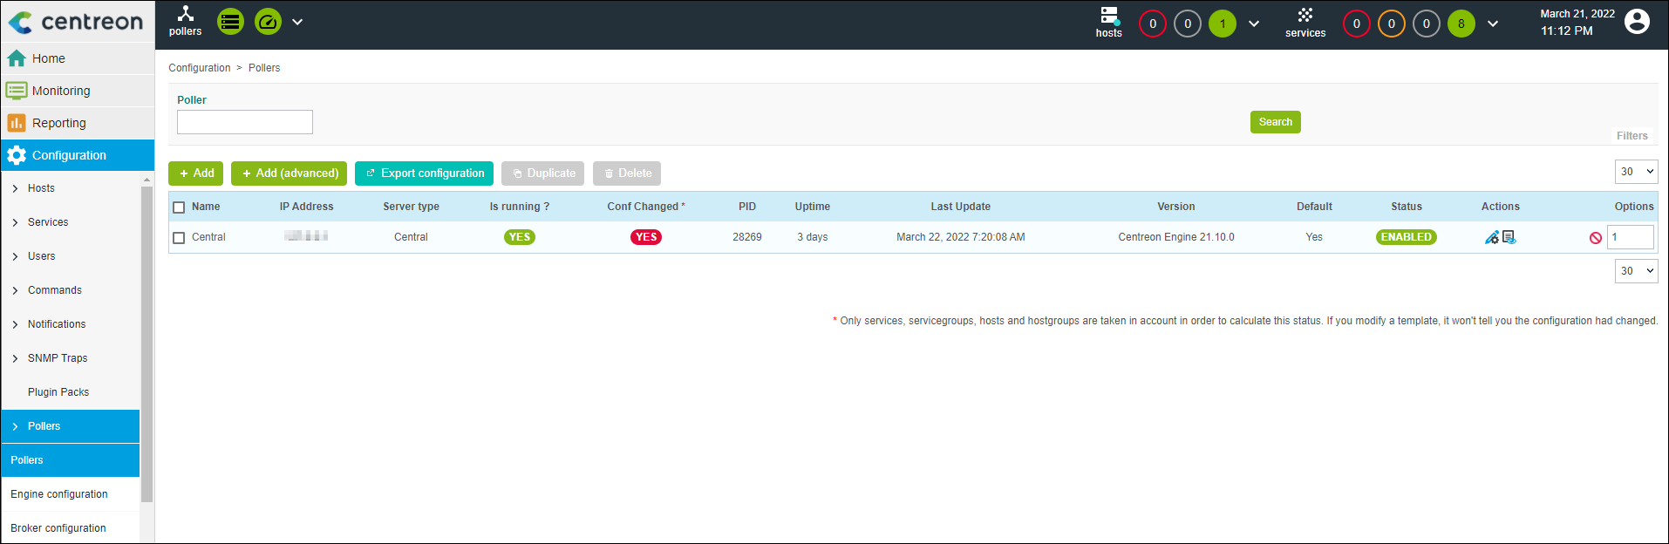

            - Select an available poller, and click Export Configuration.
            - Select all parameters in Actions, and click Export.
If Total Errors: 0 is displayed in the export results, the export is successful and the configuration takes effect.
              - Configuration Files Export page

----End

Receiving Alarms
            - Choose Monitoring > Status Details. Select All from the Service Status drop-down list box to view the alarm information.
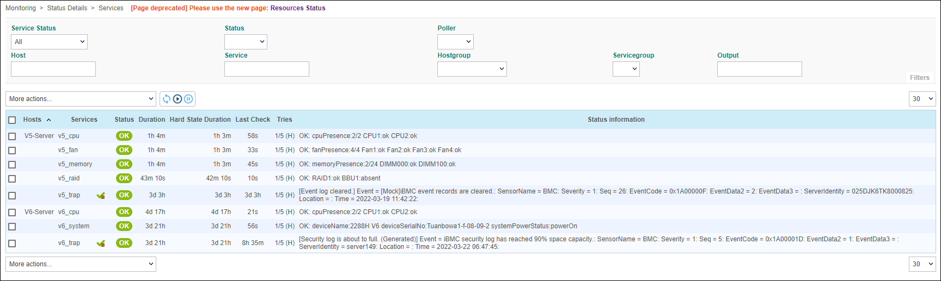
----End

Receiving SNMPv3 Alarms

Configuring a Receiving Host
            - Log in to centreon.
- Open the browser, enter http://centreon IP address/centreon in the address box, and press Enter.
- Enter the user name and password, and click Login.
The centreon home page is displayed, as shown in Figure 2-24.
              - Home page of centreon

            - Choose Configuration > Hosts > Hosts.
The Hosts page is displayed, as shown in Figure 2-25.
              - Hosts page

            - Click Add.
The Add a Host page is displayed.
Set the following parameters, as shown in Figure 2-26.
- Name: specifies the server host name.
- IP Address/DNS: specifies the server IP address.
              - Add a Host page

            - Click Save.
----End

Creating a Service and Associating it with a Host and a Trap
            - Choose Configuration > Services > Services by host.
The Services by host page is displayed, as shown in Figure Services by host page.
              - Services by host page

            - Click Add. The Add a Service page is displayed.
On the General Information tab, set the following parameters, as shown in Figure 2-28.
              - Add a Service page

The parameters are described as follows:
- Description: specifies the name of the service to be added.
- Linked with Hosts: specifies the directly connected host. You can select the host added in 2.2.2.2 Configuring a Receiving Host.
- Check Command: Select Check_centreon_dummy.
- Args:
- ARG1: Enter 0.
- ARG2: Enter OK.
- Max Check Attempts: specifies the maximum retry times.
- Normal Check Interval: specifies the regular monitoring interval.
- Retry Check Interval: specifies the interval for retrying monitoring.
- Active Checks Enabled: specifies whether to enable proactive monitoring. Set this parameter to No.
- Passive Checks Enabled: specifies whether to enable passive monitoring. Set this parameter to Yes.
- Is Volatile: Set this parameter to Default.
            - On the Relations tab, enter the associated trap information, as shown in Figure 2-29.
              - Add relations page
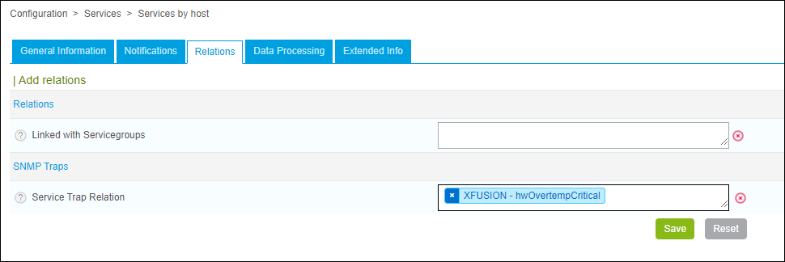

Associating with too many SNMP Traps may cause service creation failure. Select according to the requirements of your service. It is recommended that the number of associated Traps be within 1000.
            - Click Save.
----End

Generating a Configuration File and Making the ConfigurationTake Effect
            - Choose Configuration > Pollers > Pollers.
The Pollers page is displayed, as shown in Figure 2-30.
              - Pollers page

            - Select an available poller, and click Export Configuration.
            - Select all parameters in Actions, and click Export.
If Total Errors: 0 is displayed in the export results, the export is successful and the configuration takes effect.
              - Configuration Files Export page

----End

Receiving Alarms
            - Choose Monitoring > Status Details. Select All from the Service Status drop-down list box to view the alarm information.
----End
- Obtaining Technical Support
To obtain assistance, contact technical support as follows:
- Contact customer service center at support@xfusion.com.
- Contact technical support personnel.
- Communication Matrix
Source Device | Source IP Address | Source Port Number | Destination Device | Destination IP Address | Destination Port Number | Protocol | Port Description | Destination Port Configurable (Yes/No) | Authentication Mode | Encryption Mode
Device to which Centreon belongs | IP address of the device to which Centreon belongs | Random | iBMC | IP address of the device to which iBMC belongs | 161 | UDP | IBMC SNMP server port is used to obtain SNMP information. | Yes | v1 v2c: Team name  v3: Username/Password  Note: using v1 and v2c will reduce security of the system. Exercise caution when performing this operation. | SNMPV3 is subject to BMC user settings.
iBMC | IP address of the device to which iBMC belongs | Random | Device to which Centreon belongs | IP address of the device to which Centreon belongs | 162 | UDP | IBMC SNMP Trap receiving port is used to obtain SNMP Trap information. | Yes | v1 v2c: Team name  v3: Username/Password  Note: using v1 and v2c will reduce security of the system. Exercise caution when performing this operation. | None

